**Partial Fulfillment of Degree**

**A SEMINAR REPORT**

**ON**

# “Exploring Web3 from the view of blockchain”

**By**

**Viraj Vinod Koil (PRN No: 2241032)**

**T.Y. BTech (Computer Engineering), Sem-VI**

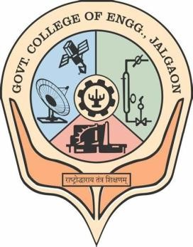

**Department of Computer Engineering**

**Government College of Engineering,**

**Jalgaon - 425001**

[An Autonomous Institute of Government of Maharashtra]

**[2023-24]**

**A**

**Seminar Report On**

**“Exploring Web3 from the view of blockchain”**

In partial fulfillment of requirements for the degree of Bachelor of Technology

In Computer Engineering

**Submitted By:**

Mr.Viraj Vinod Koli (PRN: 2241032)

**Guided by:**

Prof. Kalpana Sarode



**Department of Computer Engineering Government College of Engineering,**

**Jalgaon - 425001**

[An Autonomous Institute of Government of Maharashtra]

**[2023-24]**



**Department of Computer Engineering**

**Government College of Engineering, Jalgaon**

***CERTIFICATE***

This is to certify that the seminar entitled “Exploring Web3 from the view of blockchain**”** has been carried out by Mr. Viraj Vinod Koli (PRN: 2241032) for Subject **Seminar (CO361U)** under the guidance of **Prof.Kalpana Sarode** in partial fulfillment of the requirements for the degree of Bachelor of Technology in Computer Engineering of Government College of Engineering, Jalgaon during the academic year 2023-24(Semester-VI).

**Date:**

**Place: Jalgaon**

**Seminar Guide Seminar Coordinator**

**Prof. Kalpana Sarode Prof. T. K. Gawali**

**HOD Principal**

**Prof. Kalpana Sarode Dr. Suhas S. Gajare**